Assignment – 2
CWID: 50380788
Name: Mukesh Ravichandran

Source Code and Output Screenshots

Environment Setup

# Set the PySpark environment variables
from pyspark import SparkContext, SparkConf
from operator import add
import re
import os
os.environ["PYSPARK_PYTHON"] = r"C:\Users\mukeshravichandran\AppData\Local\Programs\Python\Python310\python.exe"
import datetime
from pyspark.sql import Row
import matplotlib.pyplot as plt
# Initialize SparkContext
sc = SparkContext("local", "NASA RDD")

Log Parsing Logic
def parseApacheLogLine(logline):
""" Parse a line in the Apache Common Log format
Args:
logline (str): a line of text in the Apache Common Log format
Returns:
tuple: either a dictionary containing the parts of the Apache Access Log and 1,
or the original invalid log line and 0
"""
match = re.search(APACHE_ACCESS_LOG_PATTERN, logline)
if match is None:
return (logline, 0)
size_field = match.group(9)
if size_field == '-':
size = int(0)
else:
size = int(match.group(9))
return (Row(
host = match.group(1),
client_identd = match.group(2),
user_id = match.group(3),
date_time = parse_apache_time(match.group(4)),
method = match.group(5),
endpoint = match.group(6),
protocol = match.group(7),
response_code = int(match.group(8)),
content_size = size
), 1)
# A regular expression pattern to extract fields from the log line
APACHE_ACCESS_LOG_PATTERN = '^(\S+) (\S+) (\S+) \[([^\]]+)\] "(\S+) (\S+) (\S+)" (\d{3}) (\S+)$'

Configuration and RDD creation
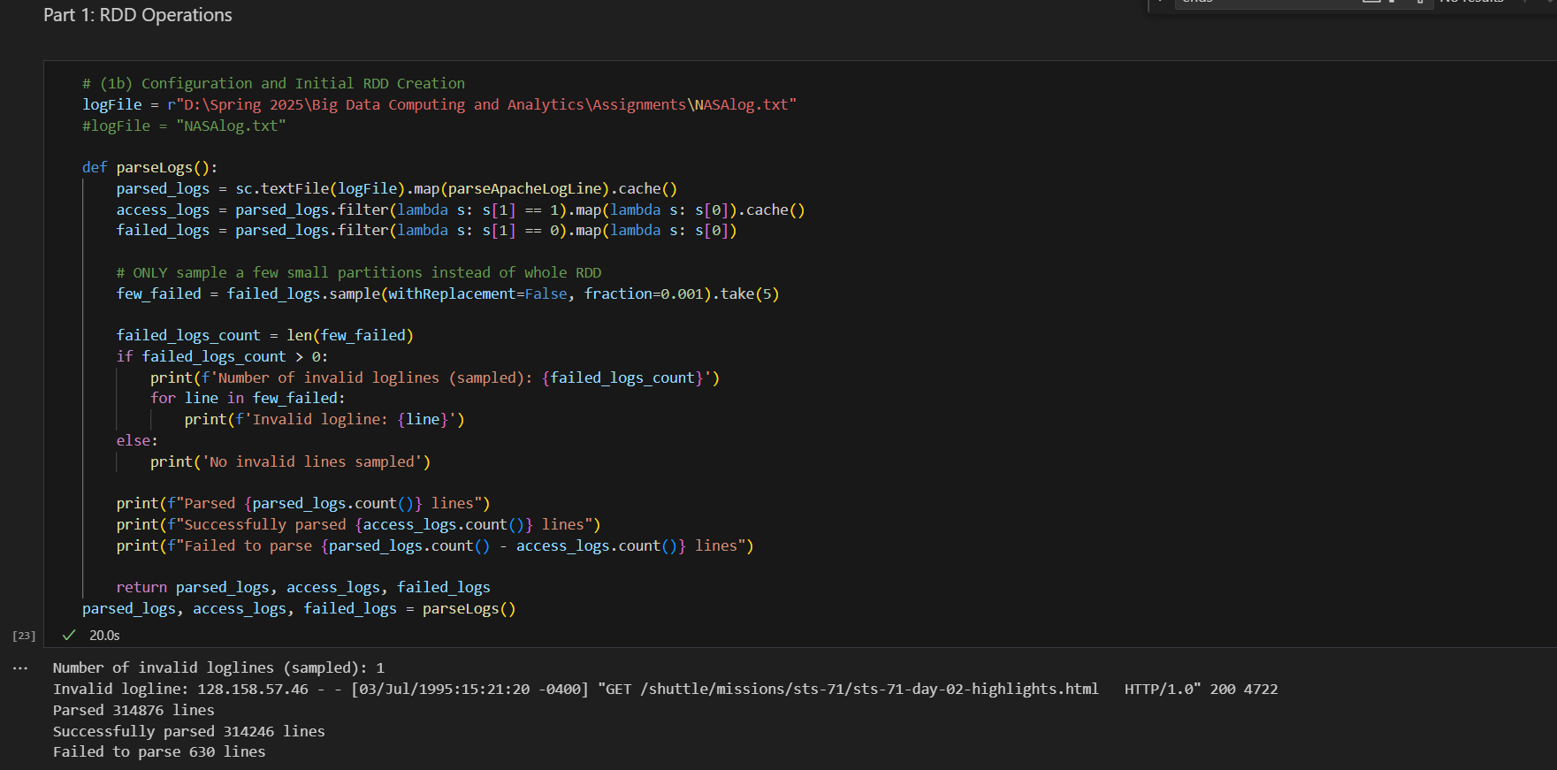

Initial Data Cleaning
630 records failed to parse. These were addressed by refining the regular expression to ensure consistent parsing.
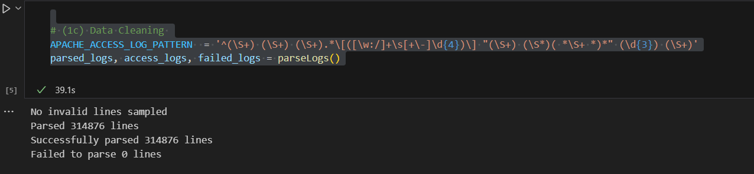

Statistics and Response Code Analysis
Content size statistics and response code frequencies were computed using reduceByKey with lambda expressions.
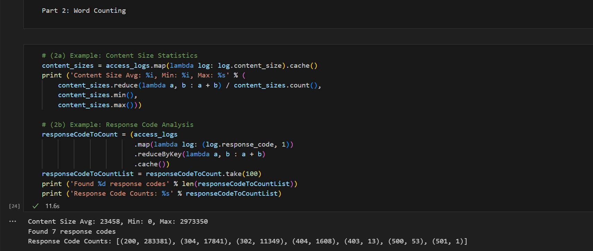

Response Code Visualization
# (2c) Example: Response Code Graphing with matplotlib
labels = responseCodeToCount.map(lambda pair: pair[0]).collect()
print(labels)
count = access_logs.count()
fracs = responseCodeToCount.map(lambda pair: float(pair[1]) / count).collect()
print(fracs)

def pie_pct_format(value):
""" Determine the appropriate format string for the pie chart percentage label
Args:
value: value of the pie slice
Returns:
str: formated string label; if the slice is too small to fit, returns an empty string for label
"""
return '' if value < 7 else '%.0f%%' % value
fig = plt.figure(figsize=(4.5, 4.5), facecolor='white', edgecolor='white')
colors = ['yellowgreen', 'lightskyblue', 'gold', 'purple', 'lightcoral', 'yellow', 'black']
explode = (0.05, 0.05, 0.1, 0, 0, 0, 0)
patches, texts, autotexts = plt.pie(fracs, labels=labels, colors=colors,
explode=explode, autopct=pie_pct_format,
shadow=False, startangle=125)
for text, autotext in zip(texts, autotexts):
if autotext.get_text() == '':
text.set_text('') # If the slice is small to fit, don't show a text label
plt.legend(labels, loc=(0.80, -0.1), shadow=True)
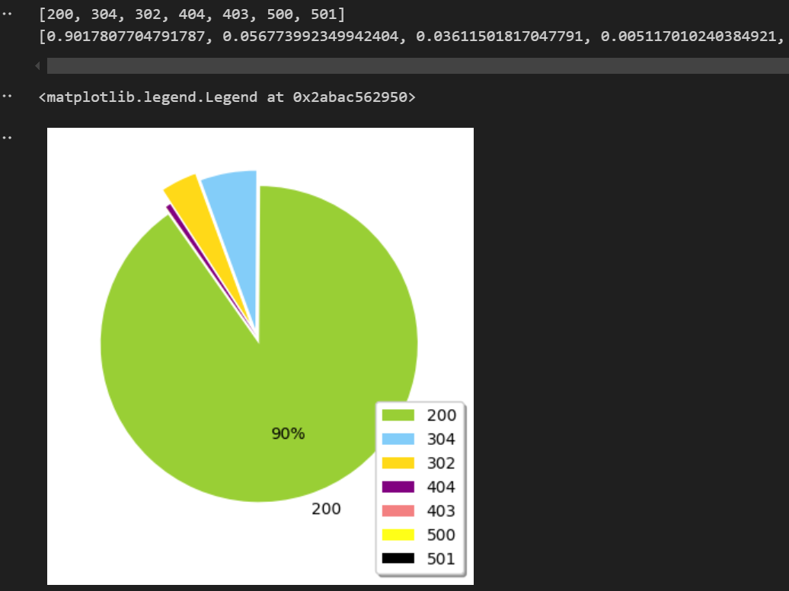

Analyzing the frequent hosts that have accessed the server
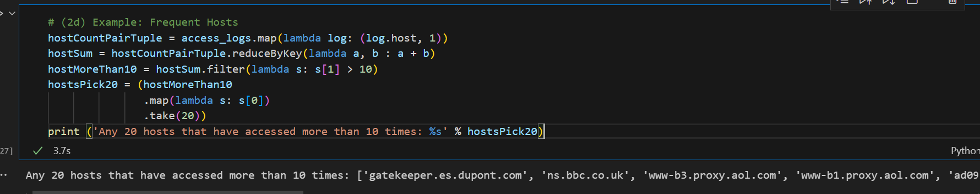

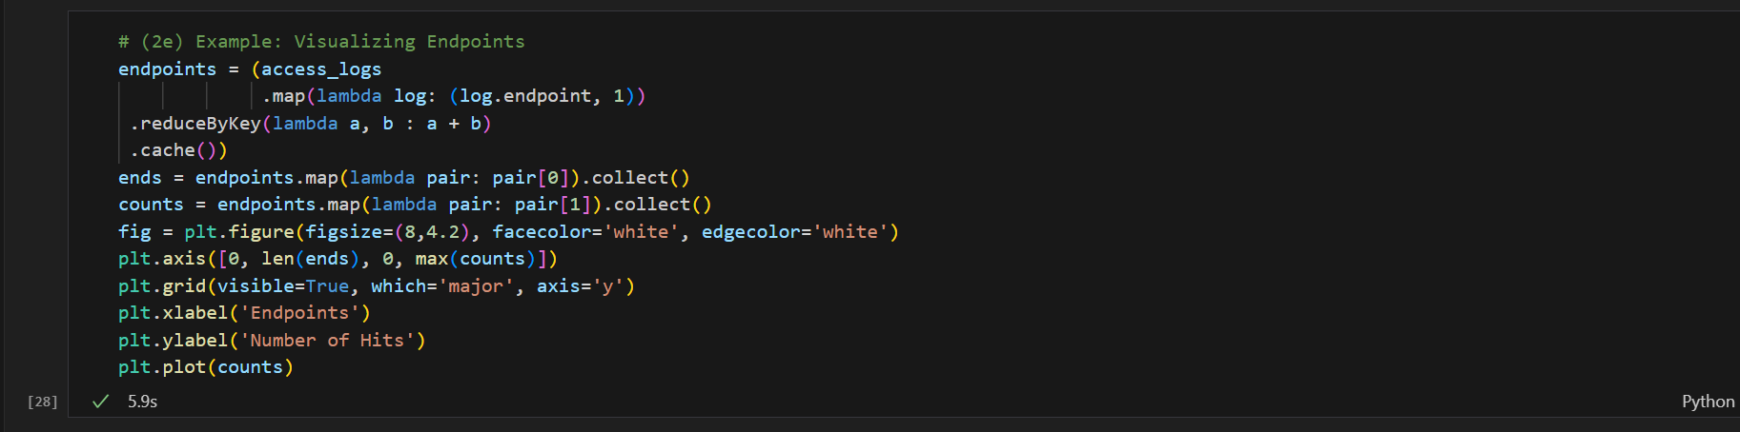
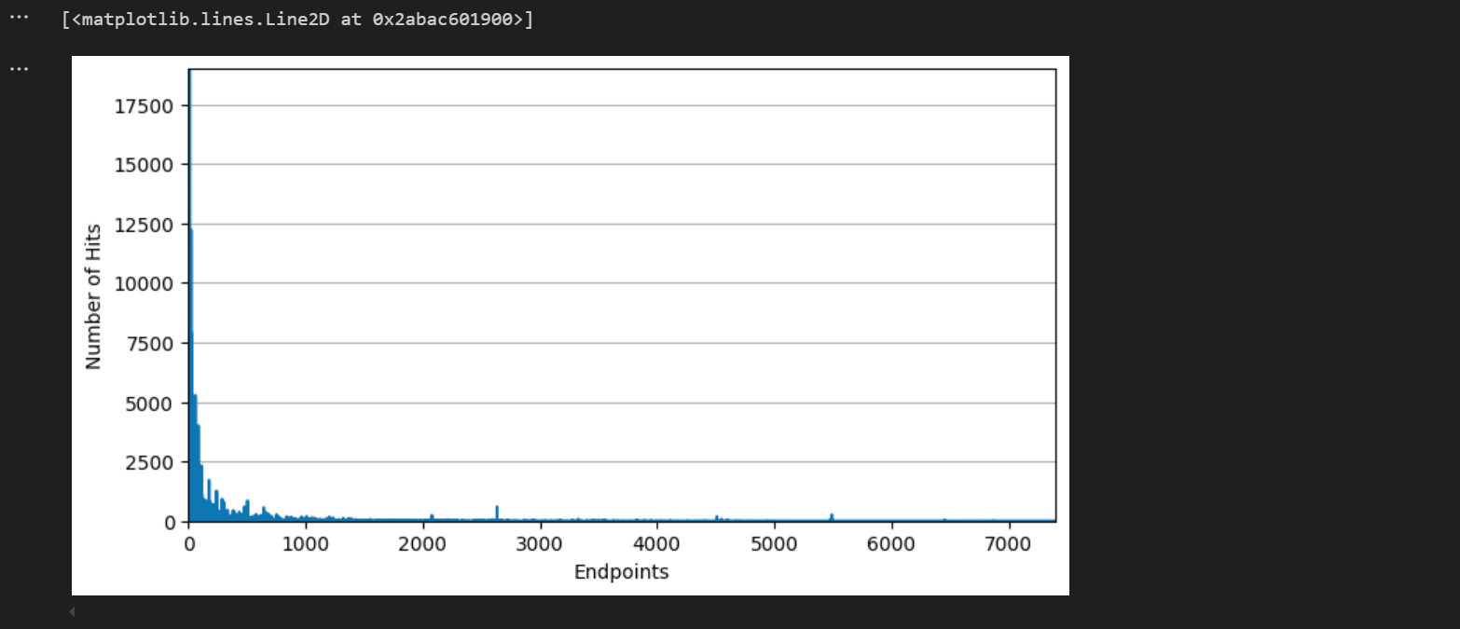

Endpoint Analysis and Visualization
Utilized reduceByKey to rank endpoints. Top 10 were visualized using a matplotlib plot.
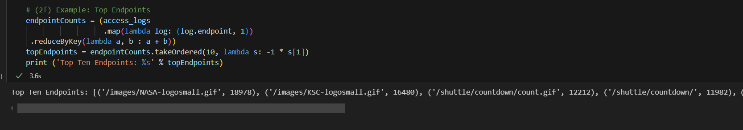

Error Endpoint Detection
Filtered records where response code ≠ 200 and sorted them by frequency to isolate the top 10 problematic endpoints.
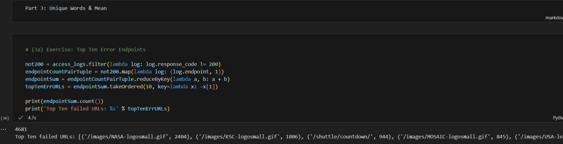

Unique Host Count
Calculated the number of distinct hosts across the logs.
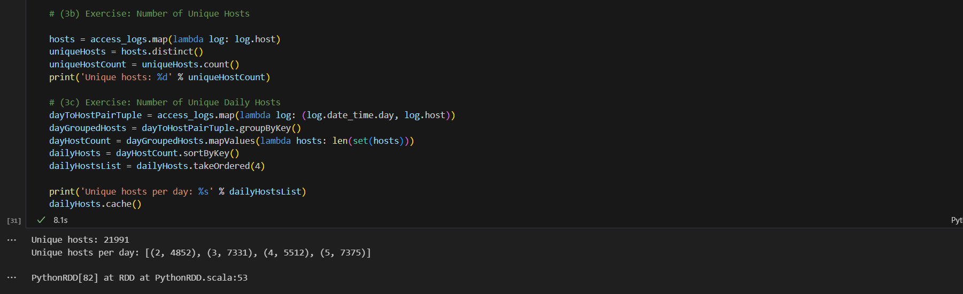

Daily Unique Host Visualization
# (3d) Exercise: Visualizing the Number of Unique Daily Hosts

daysWithHosts = dailyHosts.map(lambda x: x[0]).collect()
hosts = dailyHosts.map(lambda x: x[1]).collect()
print(daysWithHosts) # [2, 3, 4, 5, ...]
print(hosts) # [4859, 7336, 5524, 7383, ...]

fig = plt.figure(figsize=(8, 4.5), facecolor='white', edgecolor='white')
plt.axis([min(daysWithHosts), max(daysWithHosts), 0, max(hosts) + 500])
plt.grid(visible=True, which='major', axis='y')
plt.xlabel('Day')
plt.ylabel('Hosts')
plt.plot(daysWithHosts, hosts, marker='x', color='red')
plt.title('Unique Daily Hosts in July 1995')
plt.show()

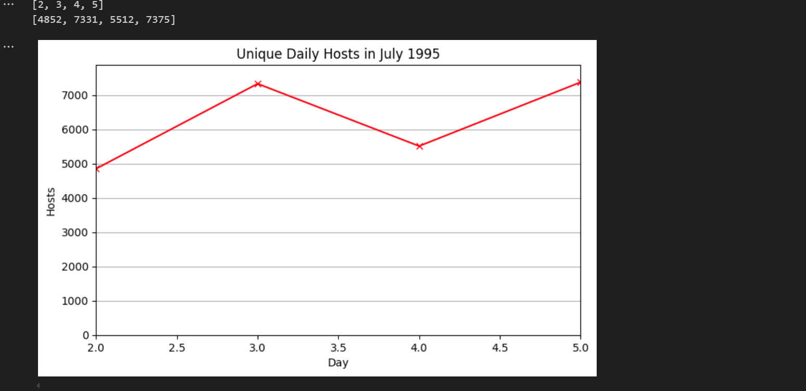
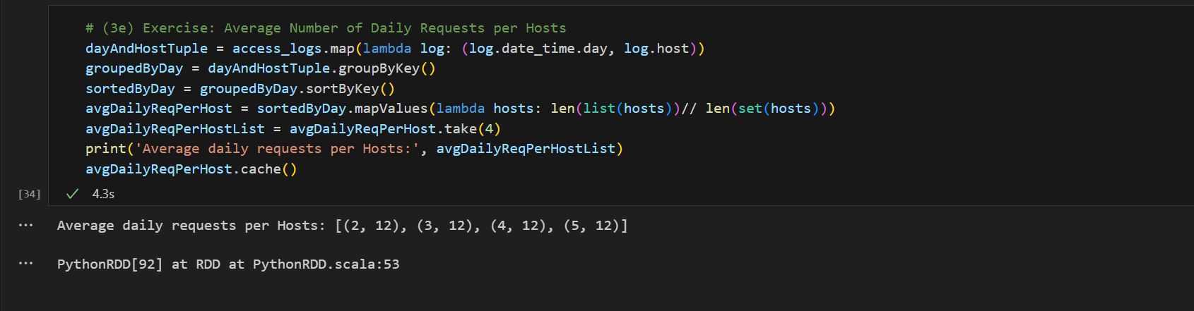
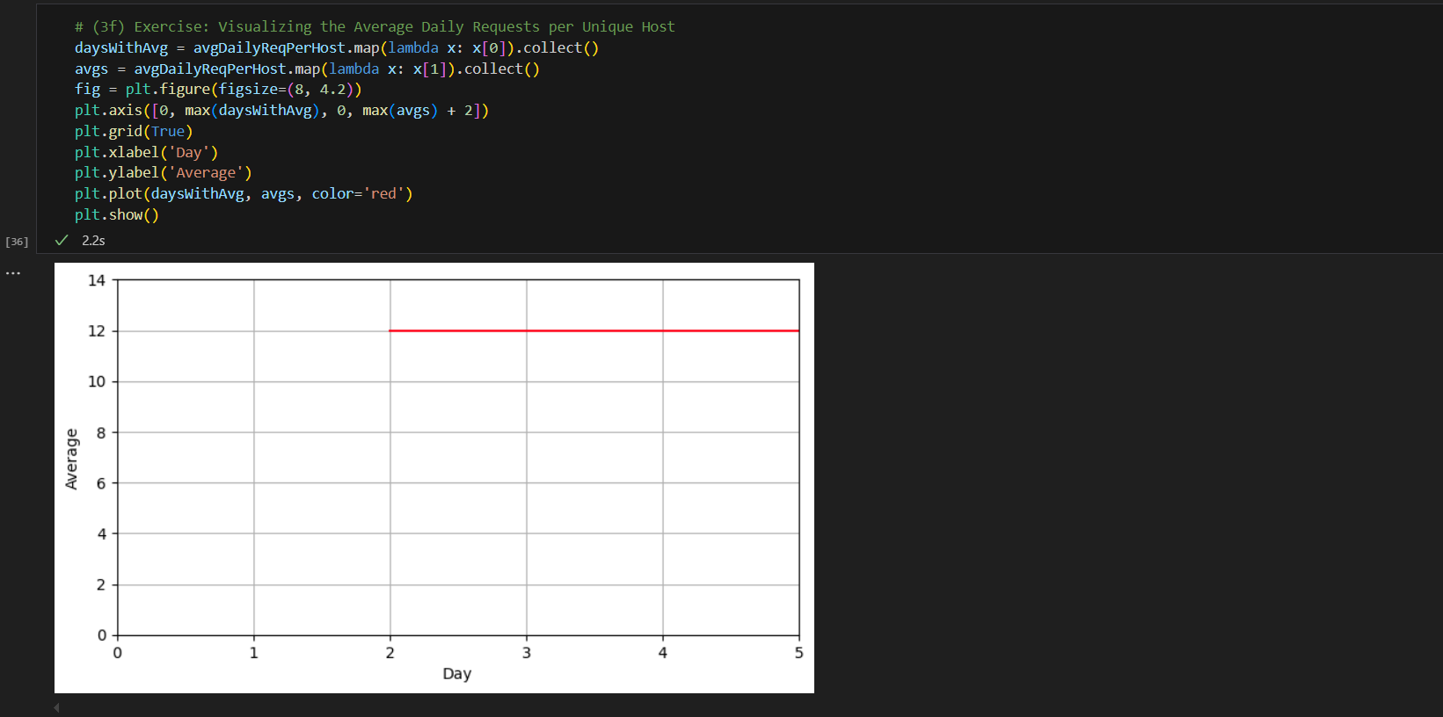

404 Response Analysis
Explored all records that returned a 404 response.
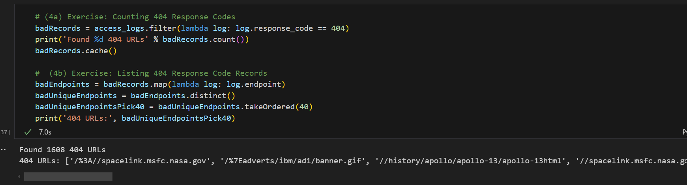
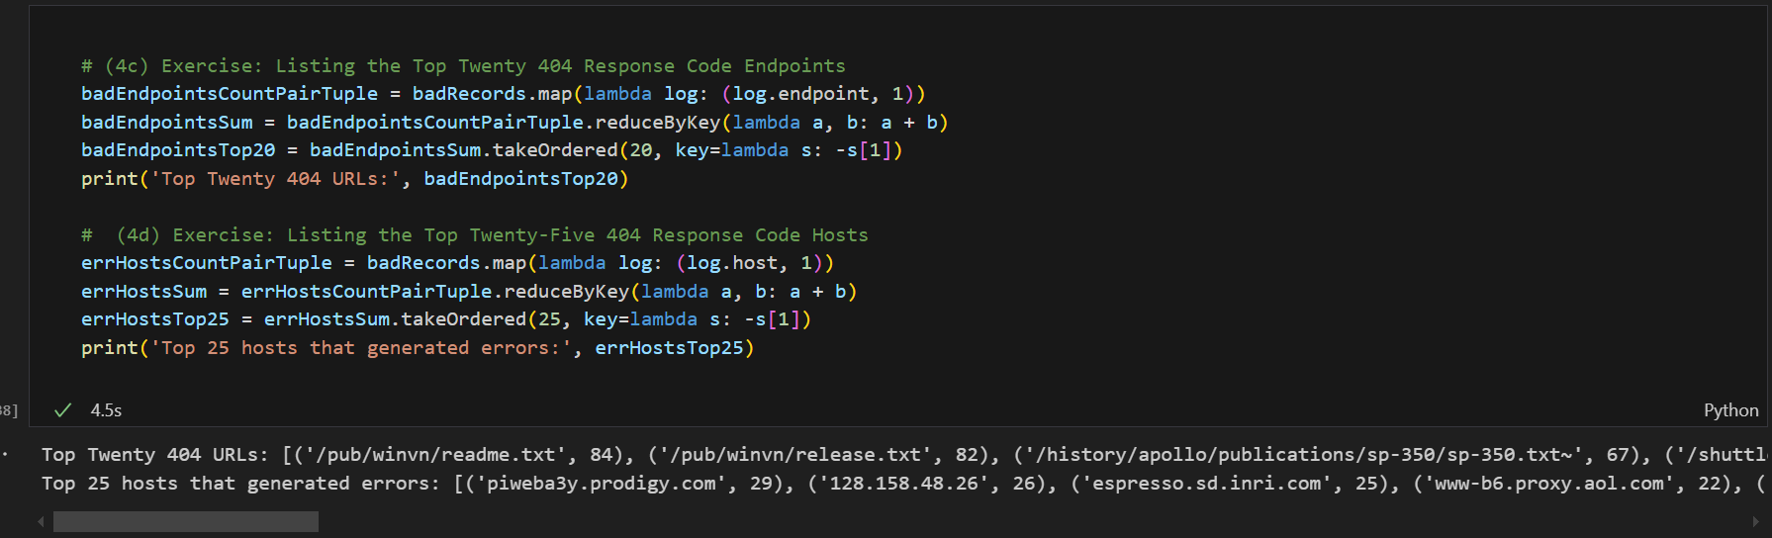
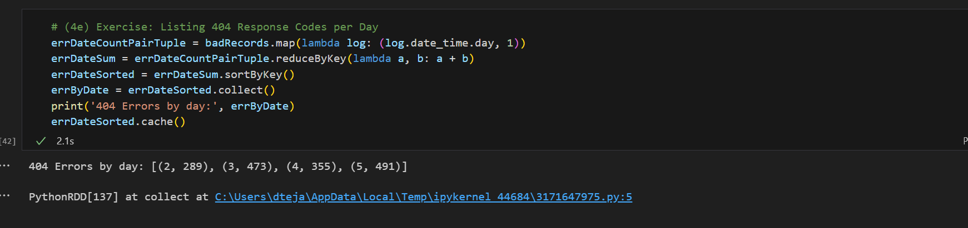
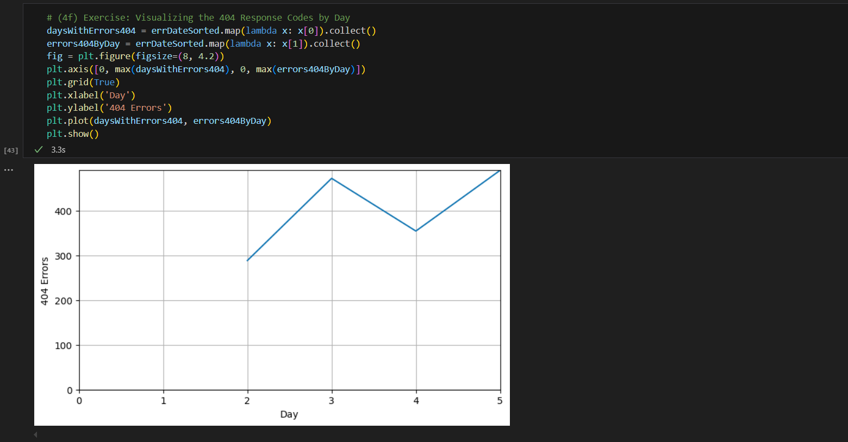
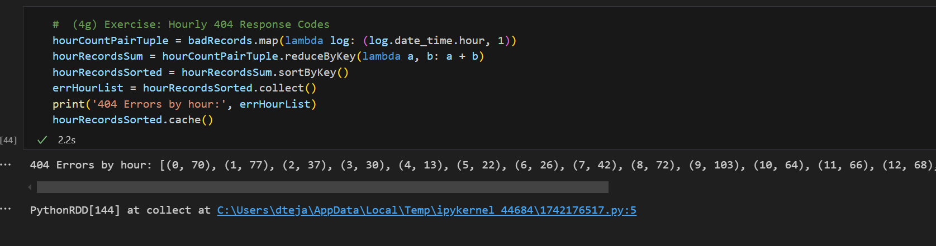

Final Steps
Visualized the findings and gracefully terminated the Spark context.
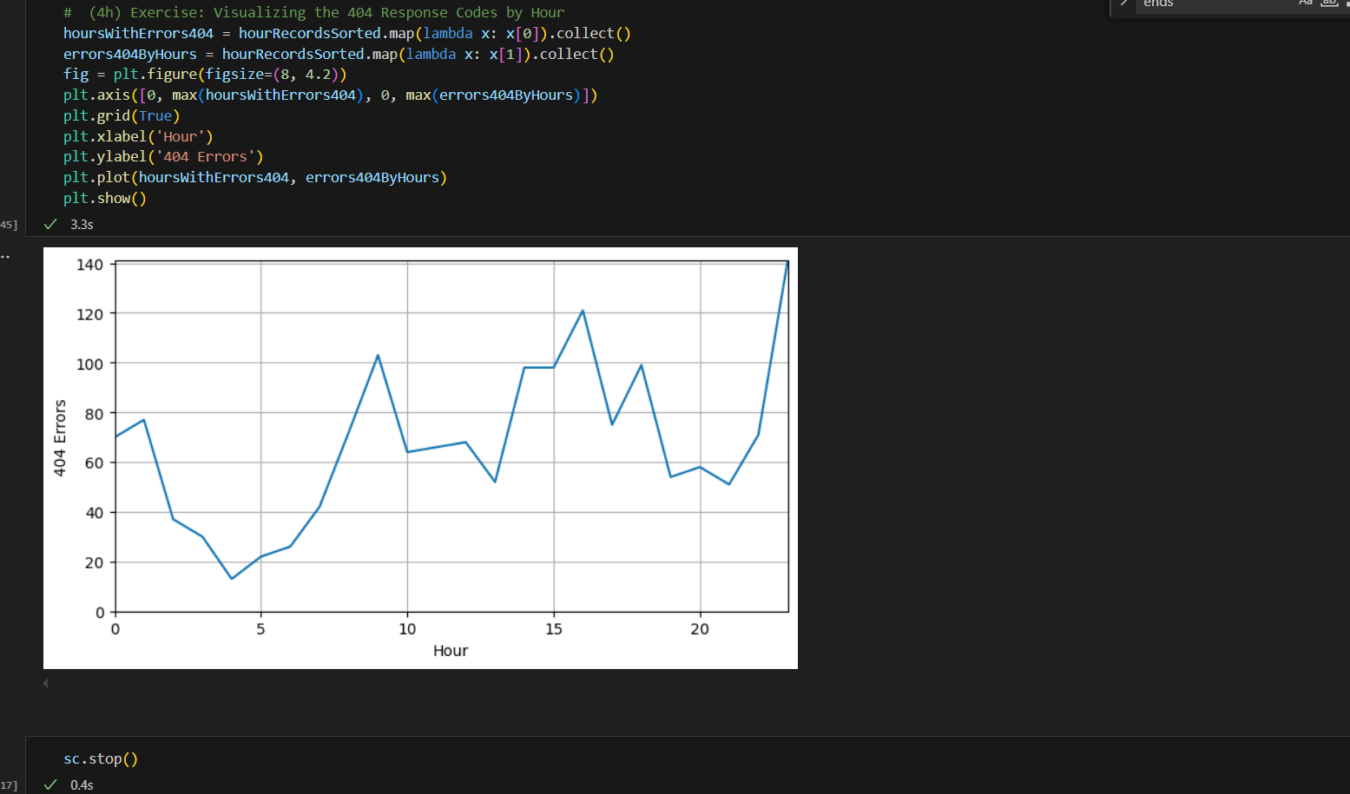

Challenges and Resolutions
- PySpark Module Not Found in Jupyter
  - Resolution: Installed PySpark in Jupyter, but due to further issues, switched to VS Code where the environment was already configured correctly.
- AttributeError for Fields like log.ip or log.date_time
  - Resolution: This error occurred because the raw text was not parsed into structured Row objects. Solved by applying the parseLogs() function before transformations.
- SparkContext Initialization Fails (ConnectionRefusedError)
  - Resolution: Resolved by checking for existing SparkContexts and stopping them before starting a new one.
- Grid Plotting Error in Matplotlib
  - Issue: Using plt.grid(b=True) raised a warning.
  - Fix: Replaced with visible=True as b is deprecated.

